# SIT315 – Programming Paradigms

TaskM2.T2C: Complex Threading

### Greg McIntyre

### 218356779

### 1. Implement a sequential version of the program and use it as your baseline to calculate execution time

<https://github.com/gregorymcintyre/ProgrammingParadigms/tree/master/M2.T2C%20-%20Complex%20Threading>

qSort.cpp, qSort.h

Quicksort is a common sorting protocol and I implemented a quicksort that meet my needs, there was no reason to reinvent the wheel for a base line calculation so, I choose a simpler more efficient path.

### 2. Implement parallel version of the program using your choice C / C++ multithreading library - OpenMP or pthreading

<https://github.com/gregorymcintyre/ProgrammingParadigms/blob/master/M2.T2C%20-%20Complex%20Threading/ComplexThreading.cpp>

I initially attempted to implement a multithread solution using OpenMP (#pragma omp parallel sections, still in code but commented out) but had compiler error and was not able to make it work, so, I implemented a pthread solution.

3. Write a document reflecting on the performance of both programs and your analysis of the decomposition you developed.

This was challenging and rewarding task, after reflecting on how the recursion would eventually cause problems with multithreaded tasks I decided to implement a two thread system after the initial pivot. In the below image I have attempted to show how I divided the array to implement a two-thread system. As the two threads do not overlap, it is safe to do so.

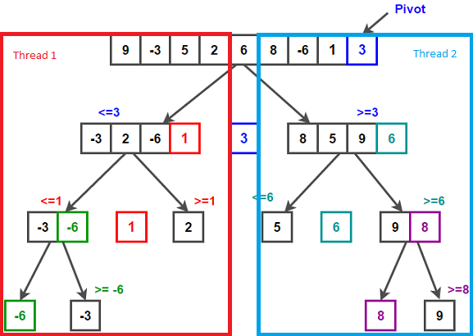

<https://www.techiedelight.com/wp-content/uploads/Quicksort.png> (Modified)

The program runs well but has an inconsistent improvement on the sequential system.

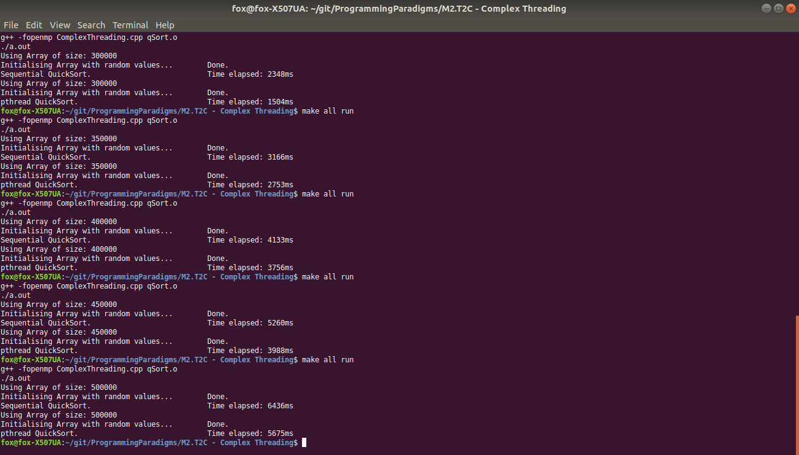

### 4. Submit your code and documentation on OnTrack

Submitted without qSort.h working git with makefile can be retrieved from git at:

<https://github.com/gregorymcintyre/ProgrammingParadigms>